**MID TERM THREE EXAMINATION – 2022**

**CLASS: PRIMARY TWO**

**SUBJECT: READING**

**Name:_______________________________________Stream: ________**

1. **Write these words correctly.**
2. lebta ____________________ b) chloso _____________________
3. **Write these sentences correctly.**
4. name my teacher’s Jane is.

___________________________________________________________

1. Ugandan She a is.

___________________________________________________________

1. **Circle the odd man out.**
2. phone, phrase, photo, fish
3. Brenda, Ruth, Paul, Betty
4. **Fill the gaps with the correct word from brackets.**
5. He was told to ______________________ the jerrycan with water. (fill, feel)
6. My grandmother lost her _____________________ at seventy years. (site, sight)
7. John bought a __________________ pair of shoes. (knew, new)
8. **Write one word using each of the spellings below.**
9. oo ___________________________ c) ph _____________________
10. ee ___________________________
11. **Write out words with long vowel /u/ spell oo from the puzzle below.**

c

b

a

|  |  |  |  |  |  |
| --- | --- | --- | --- | --- | --- |
| p | u | I | I | r | s |
| p | f | u | b | o | d |
| o | s | f | o | o | I |
| o | b | I | n | m | r |
| I | t | o | o | I | o |
| s | c | h | o | o | I |

1. **Write small words from the big one given below.**

transport

1. ____________________________ b) ____________________________
2. **Construct correct sentences using each of the pictures below.**

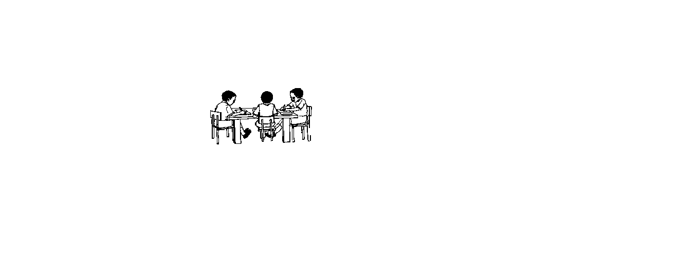 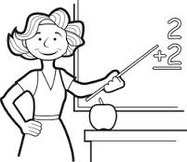

________________________________________________________

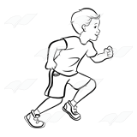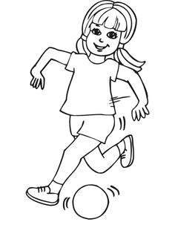

1. **Form words from the wheel.**
2. _______________________________

**n**

**f**

1. _______________________________

**p**

**ai**

1. _______________________________

**t**

**I**

**n**

**m**

1. **Rearrange these sentences to form a good story.**
2. He went back home while crying.
3. As he was coming back from the shop,
4. He went to the shop and bought sweets.
5. John’s father gave him money.
6. Some boys snatched the sweets from him.

**Good story**.

1. _____________________________________________________________
2. _____________________________________________________________
3. _____________________________________________________________
4. _____________________________________________________________
5. _____________________________________________________________
6. **Complete correctly.**
7. I am black and white in colour, I help people cross busy roads. Who am I?

____________________________________________________________

1. I am found in the bedroom. I have four legs. People sleep on me. Who am I?

____________________________________________________________

1. I can be a man or woman. I am found in the classroom. I teach learners. Who am I?

____________________________________________________________

1. **Write true of false in the gaps below.**
2. The colour of blood is red ____________________________.
3. Domestic animals are animals kept at home__________________
4. An ambulance takes people to the market __________________
5. **Read the story and answer the given questions correctly.**

**BETTY’S WORST DAY**

Betty went to school late on Monday. She reached school at 8:30 a.m. The teacher was not happy with her. He gave her a punishment. Betty cried the whole day.

**Questions**

1. Who is talked about in the story?

______________________________________________________________

1. On which day did Betty go to school late?

______________________________________________________________

1. At what time did Betty reach school?

______________________________________________________________

1. Why did Betty cry the whole day?

______________________________________________________________

1. Write the title of the story.

______________________________________________________________

1. **Use each of the words below in a sentence.**
2. to: _________________________________________________________
3. two: _______________________________________________________

***END***